

**Grizedale - Summer Term 2022**

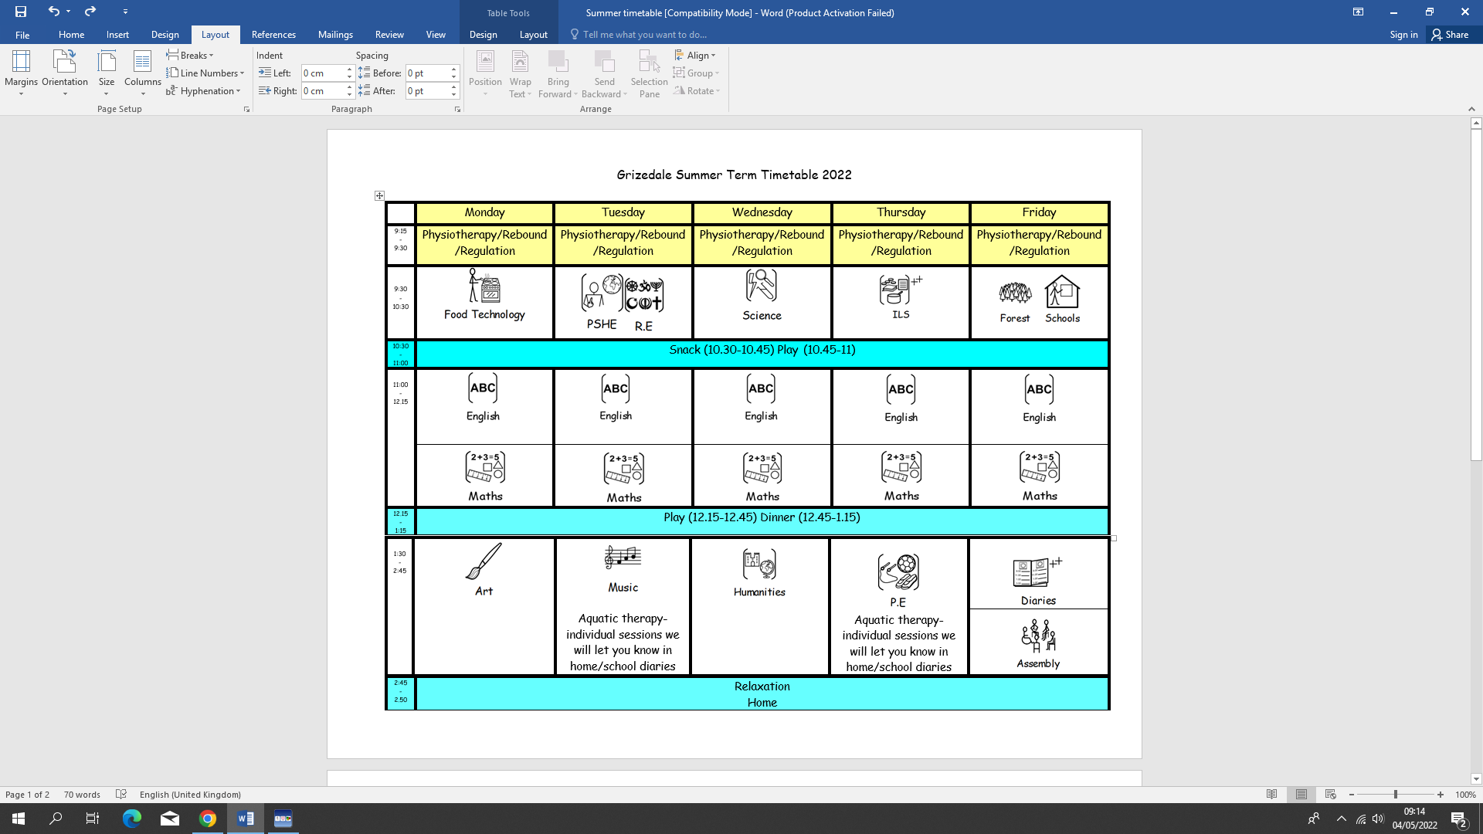

**Dates for your Diaries**

Sports Day: Friday 30th June 1.00-2.30

MOVE Festival: Thursday 23rd June

Sixth Form Awards Evening: Monday 27th June 7.00-9.00

Parents Evening – Film Night: Tuesday 12th July 6.00-8.00

Leavers Assembly: Friday 15th July 1.30

DELETE THOSE NOT REQUIRED FOR YOUR CLASS

**Things to Remember –**

Return reading books and weekly achievement diaries each week (Monday)

Bring forest schools clothes in school bags (Friday)

Swimming/shower kit when it is your child’s turn

**Dates for your Diaries**

Sports Day: Friday 30th June 1.00-2.30

MOVE Festival: Thursday 23rd June

Parents Evening – Film Night: Tuesday 12th July 6.00-8.00